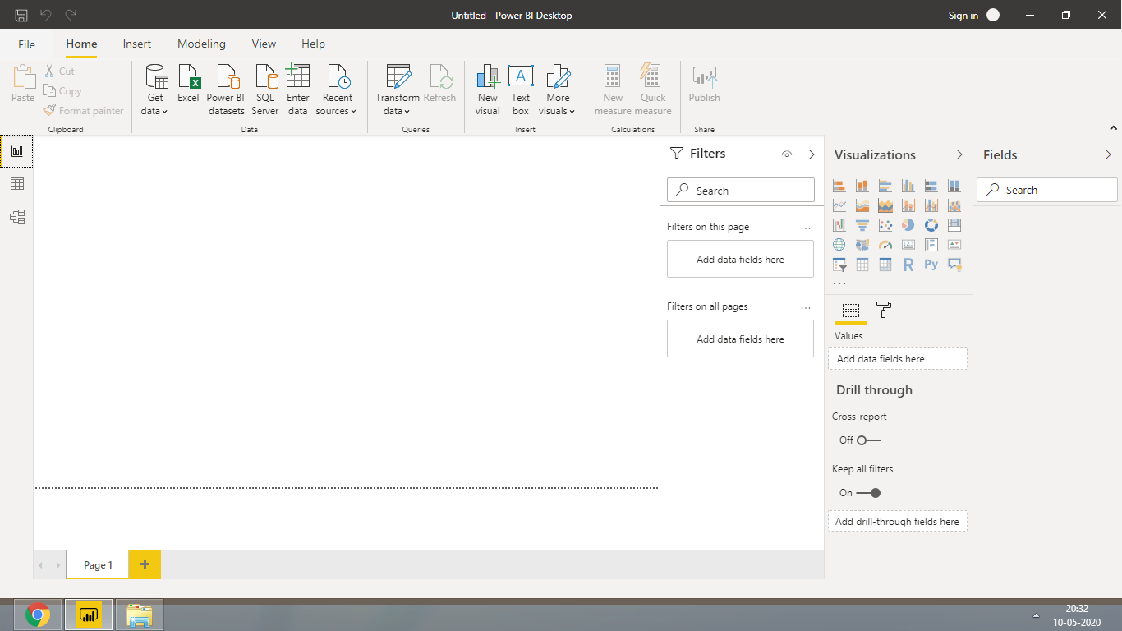

Report View:



Data View:

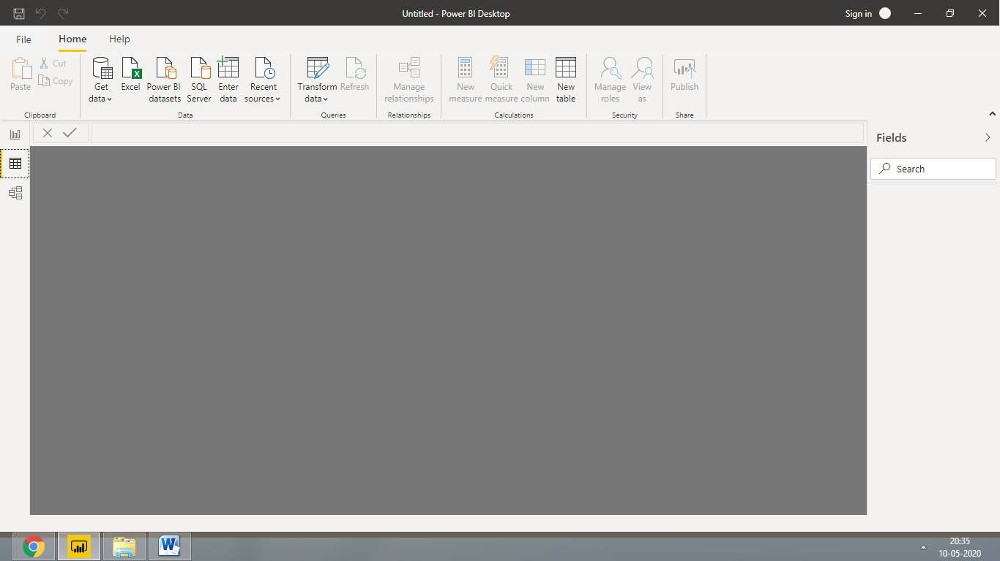

Model View:

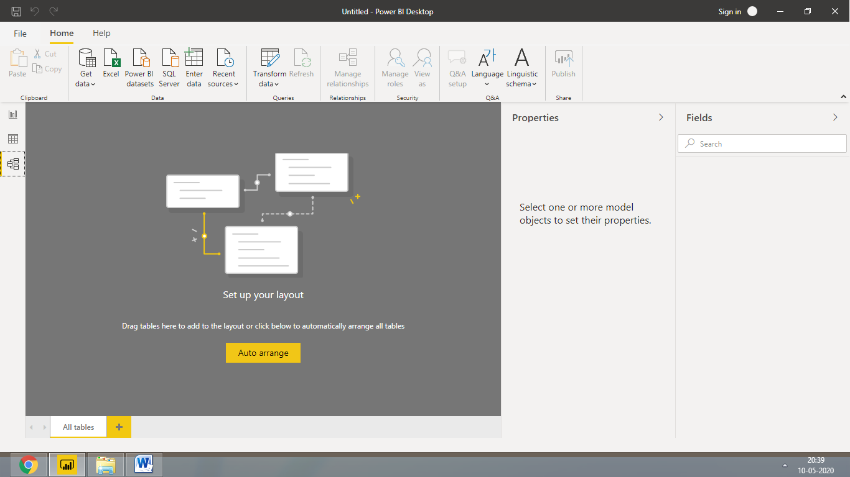

Power Query Editor:

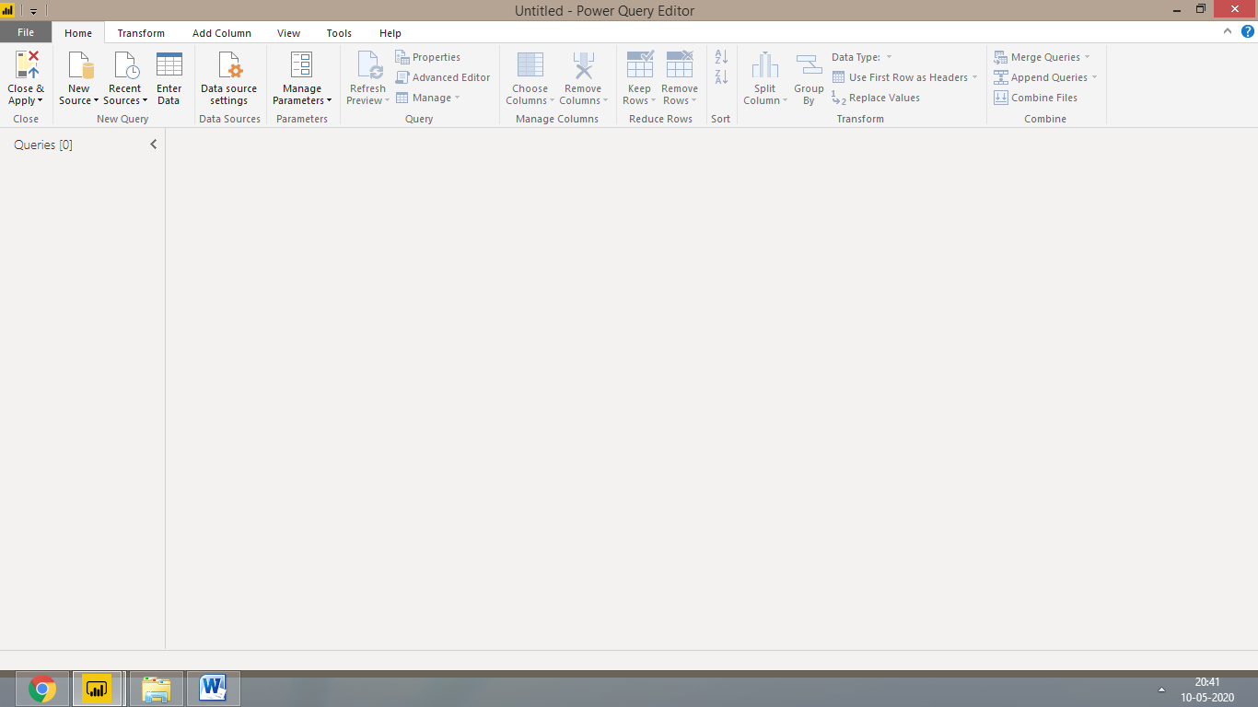

Advance Editor:

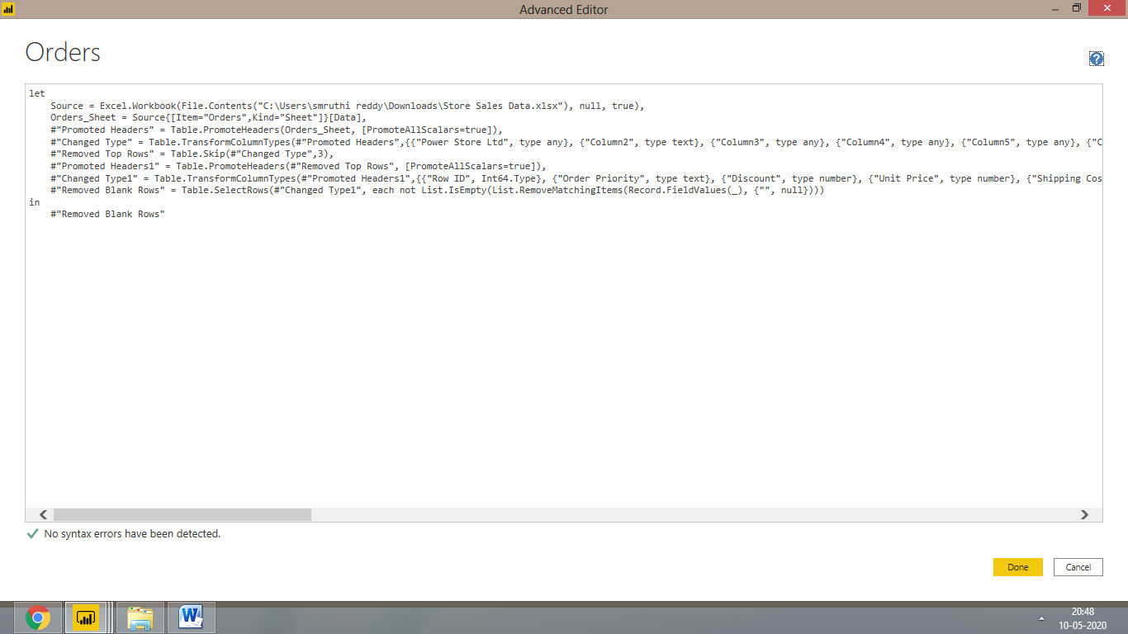

**Power BI Desktop vs Pro vs Premium**

|  |  |  |  |
| --- | --- | --- | --- |
| **Category** | **Power BI Desktop** | **Power BI Pro** | **Power BI Premium** |
| **Price** | Free | $ 9.99/user/month(Free trial for 60 days before purchasing) | $4,995 a month per dedicated cloud compute & storage resource |
| **Security** | NA | Secure | Most secure as we use the company’s capacity |
| **Sharing with peers** | Not possible | Yes | Sharing using the power BI Report Server |
| **Ability to use my firm’s hardware/storage capacity** | NA | No | Yes |
| **Usability** | Most useful where the work doesn’t need to be share d with others over server | Most useful where the users are into collaboration, data modelling, content authoring, dashboard, sharing, ad hoc analysis, and report publishing | Most useful where the users access the dashboards occasionally |